**Recruitment-exercise**

**Software Design Document**

Document update history:

version 1.0

Created by Kari Äikäs on Sep 22, 2014

Description: First version of design document

### Description

The target is to create web application for recruitment purposes. Application will ask user first name, last name, gender and reason for applying job. These values will be validated to accurate and then stored to PostgreSQL database after user press commit button. As a confirmation of successful processing stored data are displayed to user after processing is ready.

### Function Design

1. ***Inputs***

* First name (Text, Required)
* Last name (Text, Required)
* Gender (Choise of Male or Female)
* Why are you applying to this job? (Multiline Text)

1. ***local database***

Database name: user_db

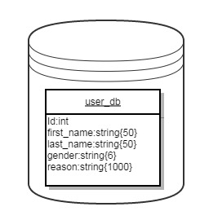

1. ***Entity class***

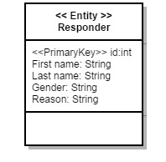

### Flowchart

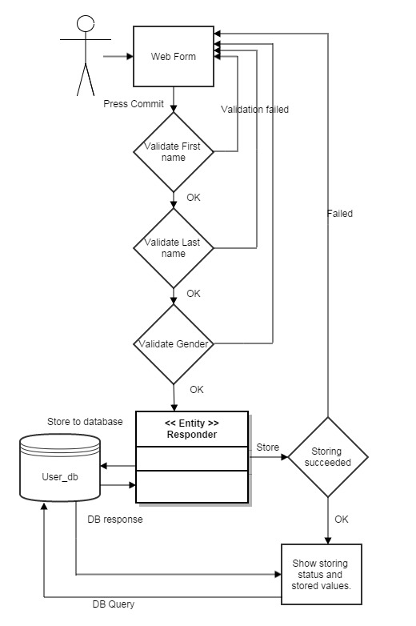

### Design decisions

Apache Maven build automation tool for building project taken into to use at project beginning. An XML file describes how the software project being built, its dependencies on other external modules and components, the build order, directories, and required plug-ins. Also possibly needed test phase are easy to include later on to project.

Web application layout and form functionality is decided to implement with using Vaadin (an open source Web application framework). It enables easy and efficient way to implement modifiable GUI components. Also possible further expansions are easy to implement and form style can be modified with CSS if needed.

Database connection decided to establish by using EclipseLink JPA solution. Such small implementation that this web form needed it was considered to be enough simple solution. Only one storing and get functions to one simple database with one table was needed. That is why quite basic approach for database connection was selected. For more complicated database table/schema case Spring JPA REST interface would be worth for implement for better usability and further development needs.

For storing form fields at once created entity class Responder which includes id, firstName, lastName, gender and reason private class variables. These are used for database interface and database table are created base to this entity class.

There is needed two entity functions storeData and getData. These uses javax.persistence functions for data persistence to PostgreSQL database.

Field validations are handled by validate function which is served by Vaadin to its components. If validation fails commit processing is stopped and user is notified about failure in inputs. Name fields are also limited to 50 characters, and only alphabetical characters and dash are allowed. Reason field is limited to 1000 characters and counter about characters are shown to user.

### System Requirement and Running Environment

Programming tool: Eclipse JavaEE IDE

Programming language: Java

Running environment: Windows

Database server: PostgreSQL

Server: Apache Tomcat

Client: IE, Mozilla, or Chrome browser

Other requirements: Maven, Vaadin, EclipseLink, JPA